**Personal Portfolio**

Team 73

Jacob Huggett – N8509905

https://github.com/jakuv/seventy-three

**Artefact 1** – (Client Requirements)

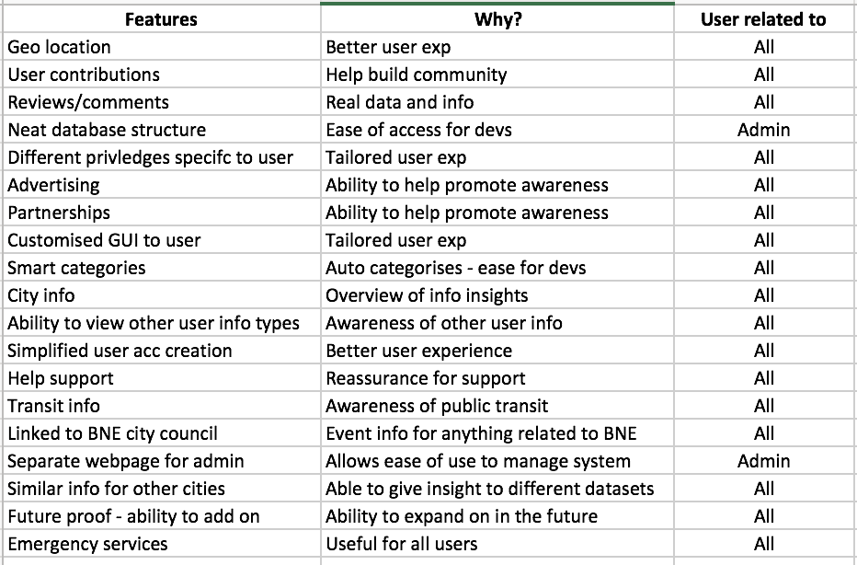

The client requirements had been created to give the CS students an idea of what the IS students believe should be a part of the webpage design for features. It helped contribute to the project by giving an insight as to what we expect for our webpage design and development.

https://github.com/jakuv/seventy-three/blob/master/Client%20Requirements.xlsx

(Relevant story from sprint – S01 – S20)

**Artefact 2** – (Meeting Minutes)

Meeting Minutes constructed over the past few weeks documenting the progress of the team.

https://github.com/jakuv/seventy-three/blob/master/Meeting%20Minutes.docx

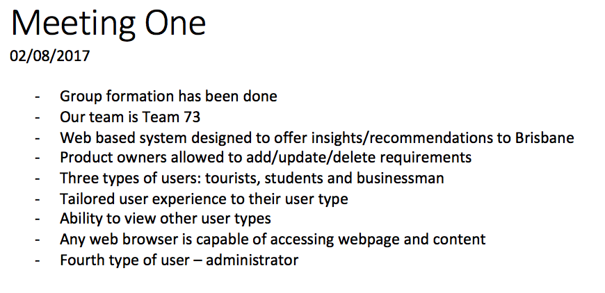

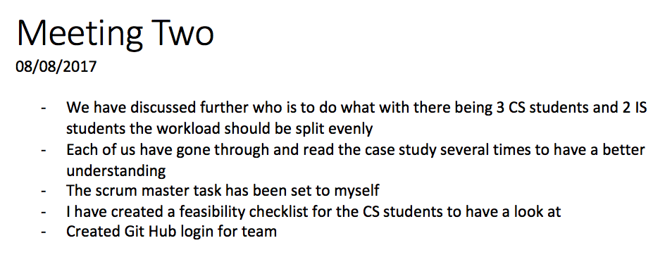

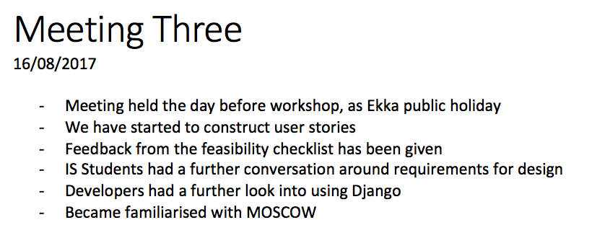

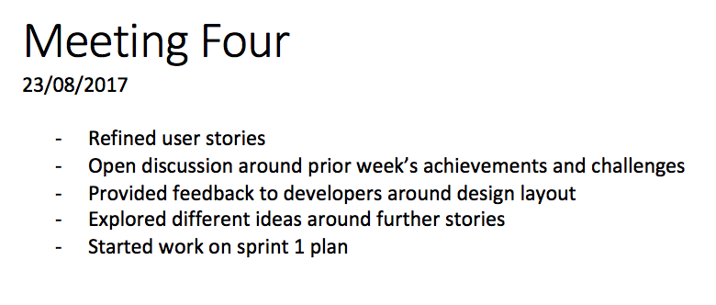

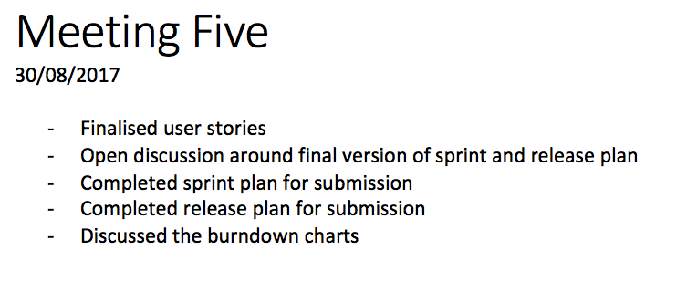

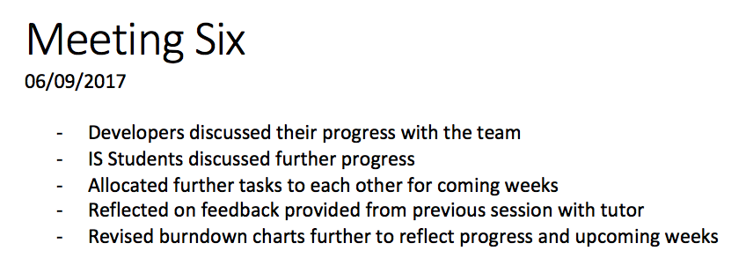

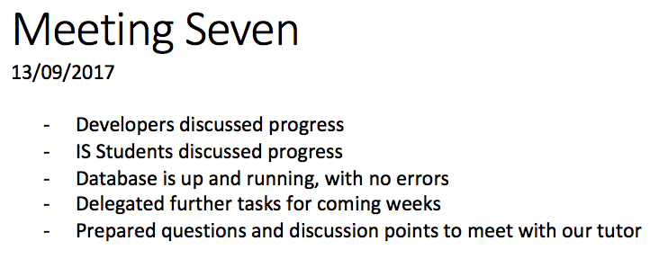

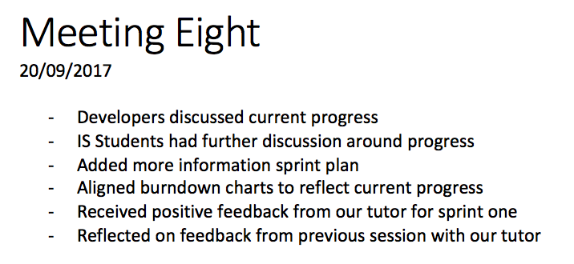

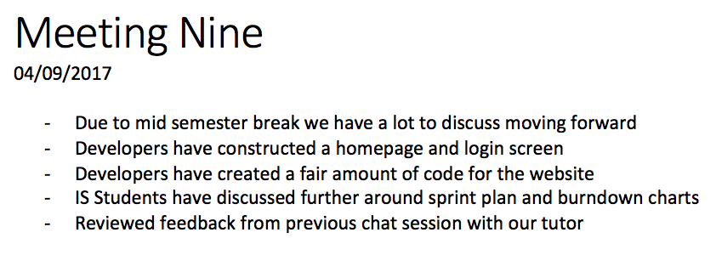

(Relevant story from sprint – Not applicable)

**Artefact 3** – (Citypal Homepage)

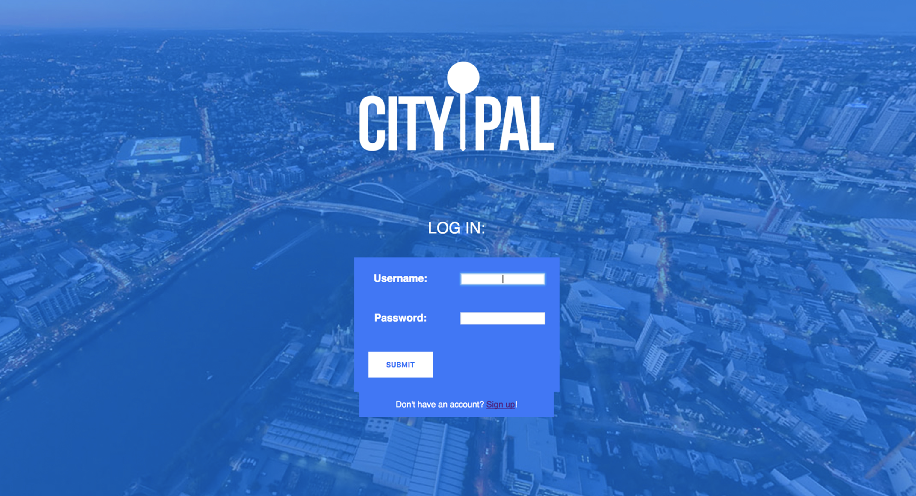

Hi-Fidelity UI of login page created by CS students with assistance from IS students for design. Users are able to log into their account or signup. The design has been constructed with an image of Brisbane city faded, with the CityPal logo and a blue effect.

https://github.com/jakuv/seventy-three/blob/master/Citypal%20Homepage.png

(Relevant story from sprint 1 – S01, S02, S04)

**Artefact 4** – (Code with Comment)

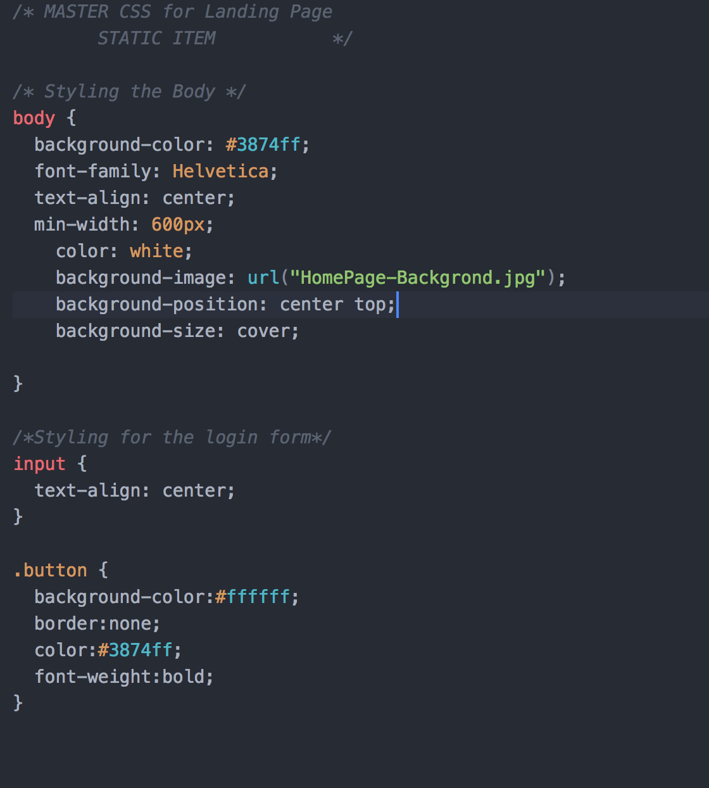

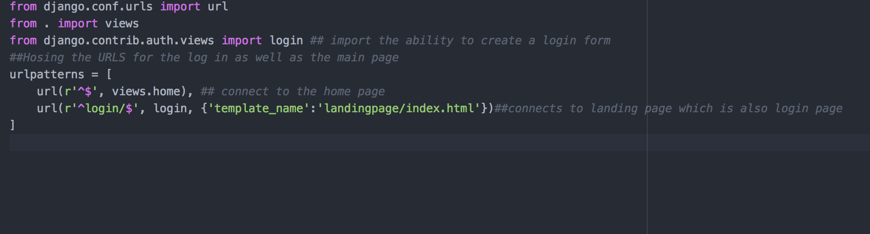

Code created by CS students and commented by IS students. Code shown reflects the homepage login screen for CityPal, with comments on different sections such as background, login boxes, text, colour and logo.

https://github.com/jakuv/seventy-three/blob/master/IFB299%201:3.png

https://github.com/jakuv/seventy-three/blob/master/IFB299%203:3.png

(Relevant story from sprint 1 - S01, S02, S04)

**Artefact 5** – (BPMN)

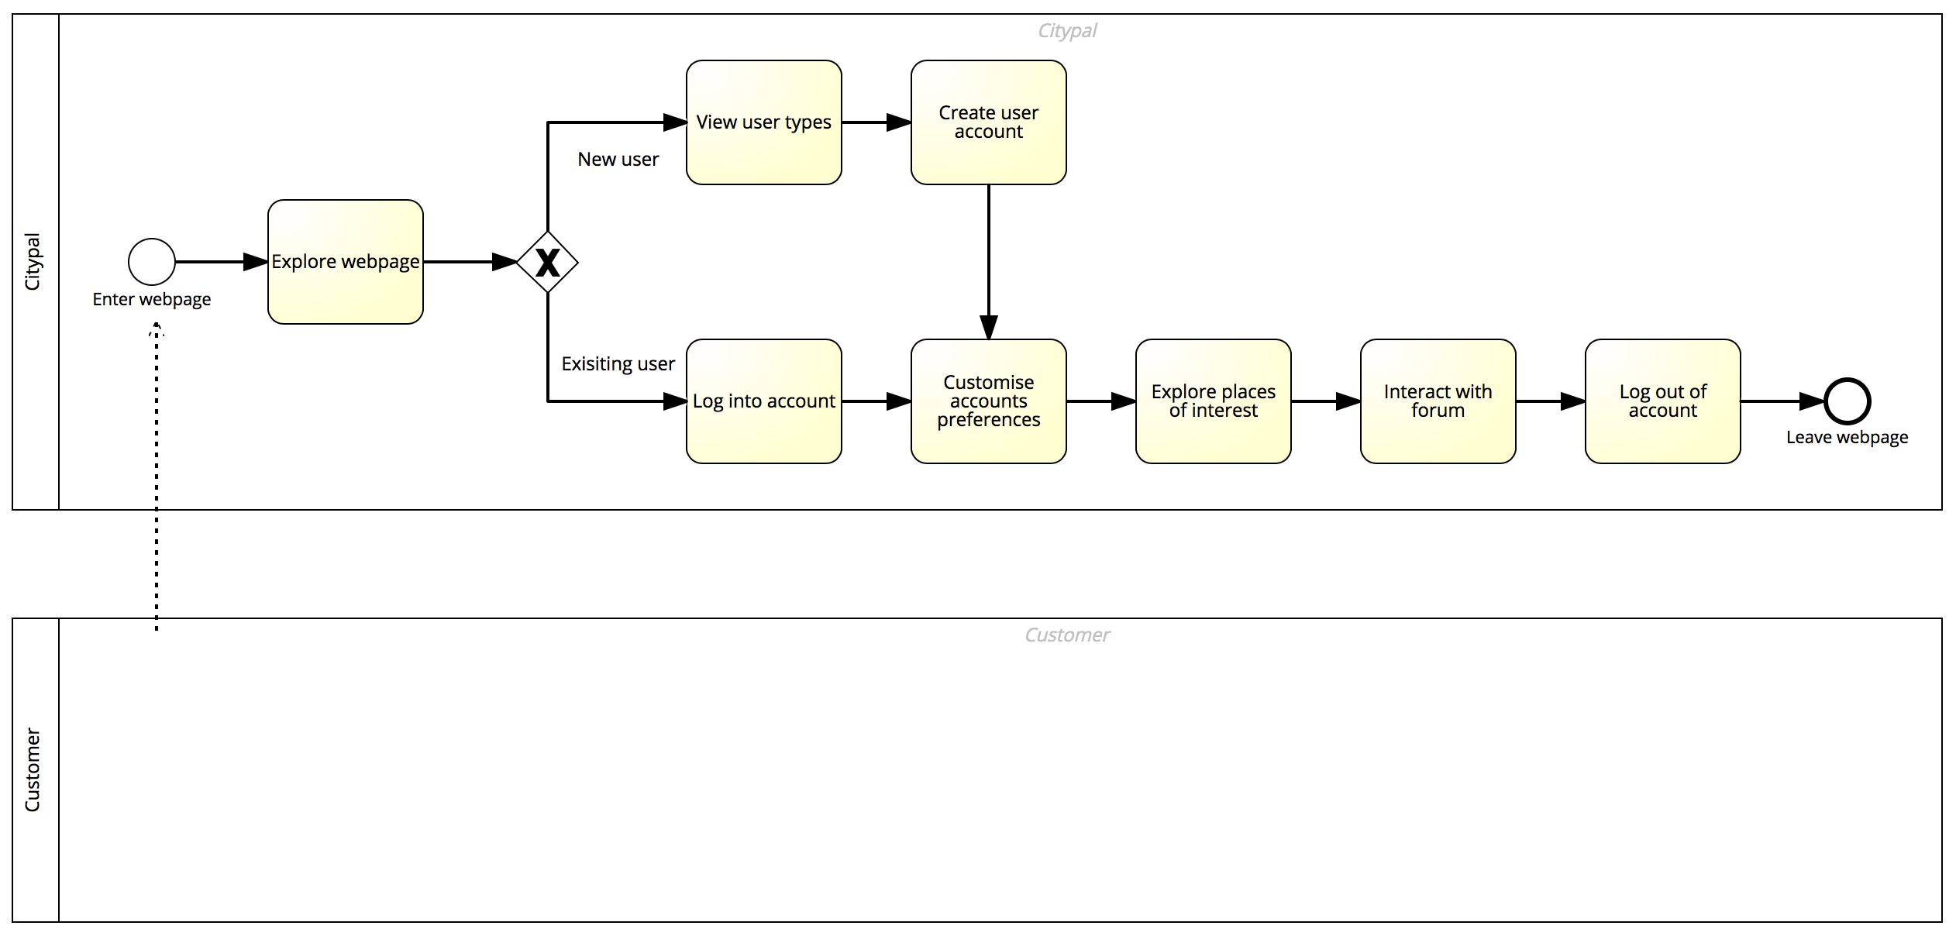

Business Process Modelling and Notation (BPMN) constructed to demonstrate the process of a new or existing user going through and interacting with the webpage from start to finish, either by creating an account or logging into their existing account.

https://github.com/jakuv/seventy-three/blob/master/IFB299%20-%20BPMN.png

(Relevant story from sprint 1 - Not applicable)